Class Activity: Risk Management – Company Profile

DrugStop Pharmacy Inc. opened in May 2012 as part of the EasyDrugs group of pharmacies. The company offers a variety of services including consultations, prescription delivery, homecare and diabetic supplies. They deliver fast and friendly service while offering personalized care for their customers.

As a new business owner, Walter Walters was looking for a feature-rich and well supported point of sale solution that would also include managing inventory, accounting, staying on top of sales trends and more. DrugStop installed the TELUS Assyst Point of Sale system to meet these needs. This solution has helped to automate their business processes, allowing them to continue to focus on providing exceptional customer service. The computers used to employ the point of sale system include a server and two terminal/workstations.

In addition, DrugStop uses TELUS Assyst Rx, a locally installed software solution for pharmacies to effectively manage patient files, prescriptions, inventory, orders, and professional info bulletins, while integration/connectivity with provincial Drug Information Systems (DIS), such as Newfoundland’s The Pharmacy Network. There is an additional server and two workstations used with the TELUS Assyst Rx software.

As a pharmacy operating in the province of Newfoundland, CANADA, DrugStop is required to adhere to the provincial Personal Health Information Act (PHIA) and participate in The Pharmacy Network. The Pharmacy Network is an online, real-time provincial drug information system which provides authorized health professionals with comprehensive medication profiles for all patients. The Pharmacy Network enables the sharing of information across the continuum of care, across healthcare delivery organizations and across geographies. Whether the information flows from a doctor's office, a clinic, hospital or pharmacy, it will appear as one patient record.

The responsibilities pharmacies have regarding Electronic Health Records (EHR) are similar to those that they have always had with respect to their patients’ information - they will have the responsibility to ensure that appropriate access to patient information is controlled at the point of service.

The Pharmacy Network is only accessible by authorized health care providers and their delegates (people that work under the supervision of authorized health care providers, such as pharmacist assistants, technicians and students). All users of the Pharmacy Network require their own username and password which, to protect privacy and confidentiality, cannot be shared.

The Pharmacy Network enables the sharing of information across the continuum of care, across healthcare delivery organizations and across geographies. Whether the information flows from a doctor's office, a clinic, hospital or pharmacy, it will appear as one patient record.

Below is an example of how information flows through the Pharmacy Network when a prescription is filled.

* Pharmacy software sends prescription information to the HIAL
* The HIAL sends messages to:
  + Client Registry to verify the patient,
  + The Provider Registry to verify both the prescriber and dispenser,
  + The DIS to check for interactions.
* Once the HIAL receives responses from Client Registry, Provider Registry, and DIS, it sends messages back to the pharmacy software showing the results

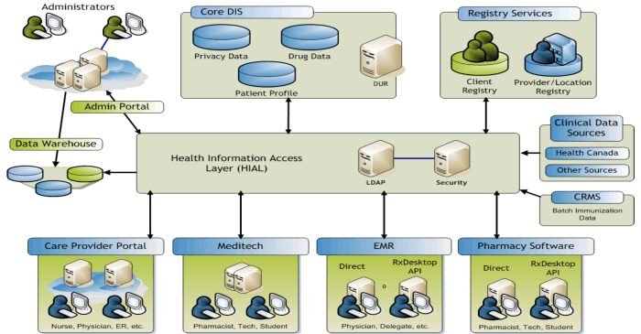

Source: <http://www.nlchi.nl.ca/pharmacy/pn_components.php>